21 April 2023

Mr. Jan Alexander Maganis

Team Manager

Alorica

Three Cyberpod Centris Edsa

Cor. Quezon Ave., Diliman

Quezon City, 1100 Metro Manila

Please accept this letter as a formal notice of my resignation from my position as Customer Service Representative with Alorica. My last day with Alorica will be May 21, 2023. It is my intention to complete all of the shifts schedule during this period.

I would like to use this opportunity to thank you for the support that you have provided me while working here at Alorica. I am very grateful for the time I have spent on our team, it’s been a pleasure working for you.

Thank you again, I wish you all the best and hope to stay in touch.

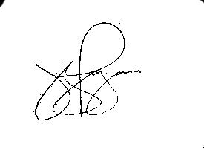

Sincerely,

Jasmine Nicole Bautista Lajara